**OSPF Routing**

Student Version



Huawei Technologies Co., Ltd.

|  |
| --- |
| **Copyright © Huawei Technologies Co., Ltd. 2020. All rights reserved.**  No part of this document may be reproduced or transmitted in any form or by any means without prior written consent of Huawei Technologies Co., Ltd.  **Trademarks and Permissions**  HW_POS_RBG_Vertical-150ppi.png and other Huawei trademarks are trademarks of Huawei Technologies Co., Ltd.  All other trademarks and trade names mentioned in this document are the property of their respective holders.  **Notice**  The purchased products, services and features are stipulated by the contract made between Huawei and the customer. All or part of the products, services and features described in this document may not be within the purchase scope or the usage scope. Unless otherwise specified in the contract, all statements, information, and recommendations in this document are provided "AS IS" without warranties, guarantees or representations of any kind, either express or implied.  The information in this document is subject to change without notice. Every effort has been made in the preparation of this document to ensure accuracy of the contents, but all statements, information, and recommendations in this document do not constitute a warranty of any kind, express or implied. |

|  |  |
| --- | --- |
| Huawei Technologies Co., Ltd. | |
| Address: | Huawei Industrial Base  Bantian, Longgang  Shenzhen 518129  People's Republic of China |
| Website: | <https://e.huawei.com/> |

**Huawei Certification System**

Huawei Certification follows the "platform + ecosystem" development strategy, which is a new collaborative architecture of ICT infrastructure based on "Cloud-Pipe-Terminal". Huawei has set up a complete certification system consisting of three categories: ICT infrastructure certification, platform and service certification, and ICT vertical certification. It is the only certification system that covers all ICT technical fields in the industry. Huawei offers three levels of certification: Huawei Certified ICT Associate (HCIA), Huawei Certified ICT Professional (HCIP), and Huawei Certified ICT Expert (HCIE). Huawei Certification covers all ICT fields and adapts to the industry trend of ICT convergence. With its leading talent development system and certification standards, it is committed to fostering new ICT talent in the digital era, and building a sound ICT talent ecosystem.

Huawei Certified ICT Associate-Datacom (HCIA-Datacom) is designed for Huawei's frontline engineers and anyone who want to understand Huawei's datacom products and technologies. The HCIA-Datacom certification covers routing and switching principles, basic WLAN principles, network security basics, network management and O&M basics, SDN and programmability and automation basics.

The Huawei certification system introduces the industry, fosters innovation, and imparts cutting-edge datacom knowledge.

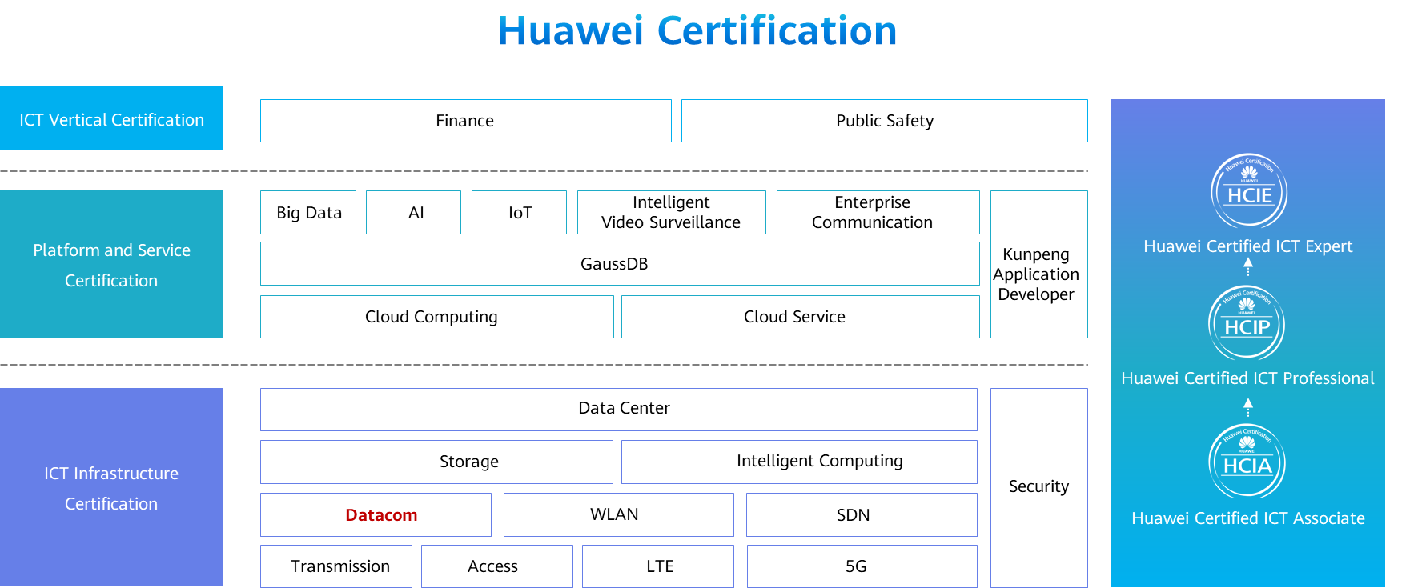

# OSPF Routing

## Background

The Open Shortest Path First (OSPF) protocol is a link-state Interior Gateway Protocol (IGP) developed by the Internet Engineering Task Force (IETF). Currently, OSPF Version 2 (RFC2328) is used for IPv4. As a link-state protocol, OSPF has the following advantages:

Multicast packet transmission to reduce load on the switches that are not running OSPF

Classless Inter-Domain Routing (CIDR)

Load balancing among equal-cost routes

Packet authentication

With the preceding advantages, OSPF is widely accepted and used as an IGP.

In the lab activity, you will understand basic OSPF configurations and principles by configuring single-area OSPF.

## Objectives

Upon completion of this task, you will be able to:

Learn the basic commands of OSPF

Learn how to check the OSPF running status

Learn how to control OSPF route selection using costs

Understand the advertisement of default routes in OSPF

Learn how to configure OSPF authentication

## Topology

Lab Topology

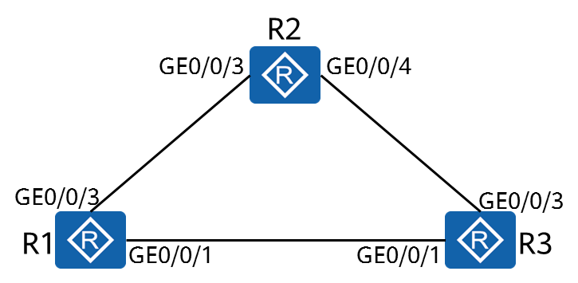

R1, R2, and R3 are gateways of their networks. You need to configure OSPF to enable connectivity between the networks.

## Implementation

### Roadmap

1. Create OSPF processes on the devices and enable OSPF on the interfaces.
2. Configure OSPF authentication.
3. Configure OSPF to advertise default routes.
4. Control OSPF route selection using costs.

### Procedure

Complete basic device configuration.

# Follow steps 1, 2, 3, and 4 in the lab《IPv4 Addressing and Routing》to name the routers and configure the IP addresses of the physical and loopback interfaces.

# Display the routing table on the router (R1 in this example).

[R1]display ip routing-table

Route Flags: R - relay, D - download to fib

------------------------------------------------------------------------------

Routing Tables: Public

Destinations : 11 Routes : 11

Destination/Mask Proto Pre Cost Flags NextHop Interface

10.0.1.1/32 Direct 0 0 D 127.0.0.1 LoopBack0

10.0.12.0/24 Direct 0 0 D 10.0.12.1 GigabitEthernet0/0/3

10.0.12.1/32 Direct 0 0 D 127.0.0.1 GigabitEthernet0/0/3

10.0.12.255/32 Direct 0 0 D 127.0.0.1 GigabitEthernet0/0/3

10.0.13.0/24 Direct 0 0 D 10.0.13.1 GigabitEthernet0/0/1

10.0.13.1/32 Direct 0 0 D 127.0.0.1 GigabitEthernet0/0/1

10.0.13.255/32 Direct 0 0 D 127.0.0.1 GigabitEthernet0/0/1

127.0.0.0/8 Direct 0 0 D 127.0.0.1 InLoopBack0

127.0.0.1/32 Direct 0 0 D 127.0.0.1 InLoopBack0

127.255.255.255/32 Direct 0 0 D 127.0.0.1 InLoopBack0

255.255.255.255/32 Direct 0 0 D 127.0.0.1 InLoopBack0

*At this point, only direct routes exist on the device.*

Complete the basic OSPF configuration.

# Create an OSPF process.

[R1]

You can set OSPF parameters only after creating an OSPF process. OSPF supports multiple independent processes on one device. Route exchange between different OSPF processes is similar to that between different routing protocols. You can specify a process ID when creating an OSPF process. If no process ID is specified, the default process ID 1 is used.

# Create an OSPF area and specify the interfaces on which OSPF is to be enabled.

[R1-ospf-1]

The **area** command creates an OSPF area and displays the OSPF area view.

[R1-ospf-1-area-0.0.0.0]

[R1-ospf-1-area-0.0.0.0]

[R1-ospf-1-area-0.0.0.0]

The **network** *network-address wildcard-mask* command specifies the interfaces on which OSPF is to be enabled. OSPF can run on an interface only when the following two conditions are met:

1. The mask length of the interface's IP address is not shorter than that specified in the **network** command. OSPF uses reverse mask. For example 0.0.0.255 indicates that the mask length is 24 bits.
2. The address of the interface must be within the network range specified in the **network** command.

In this example, OSPF can be enabled on the three interfaces, and they are all added to area 0.

[R2]ospf

[R2-ospf-1]area 0

[R2-ospf-1-area-0.0.0.0]

If the wildcard mask in the **network** command is all 0s and the IP address of the interface is the same as the IP address specified in the **network-address** command, the interface also runs OSPF.

[R3]ospf

[R3-ospf-1]area 0

[R3-ospf-1-area-0.0.0.0]

Display the OSPF status.

# Displays the OSPF neighbor information.

[R1]display ospf peer

OSPF Process 1 with **Router ID 10.0.1.1**

Neighbors

**Area 0.0.0.0** interface 10.0.13.1(GigabitEthernet0/0/1)'s neighbors

Router ID: **10.0.1.3**  Address: **10.0.13.3**

State: **Full**  Mode:Nbr is Master Priority: 1

**DR: 10.0.13.3 BDR: 10.0.13.1** MTU: 0

Dead timer due in 36 sec

Retrans timer interval: 0

Neighbor is up for 00:00:30

Authentication Sequence: [ 0 ]

Neighbors

Area 0.0.0.0 interface 10.0.12.1(GigabitEthernet0/0/3)'s neighbors

Router ID: **10.0.1.2** Address: **10.0.12.2**

State: Full Mode:Nbr is Master Priority: 1

DR: **10.0.12.2** BDR: **10.0.12.1** MTU: 0

Dead timer due in 39 sec

Retrans timer interval: 4

Neighbor is up for 00:00:28

Authentication Sequence: [ 0 ]

The **display ospf peer** command displays information about neighbors in each OSPF area. The information includes the area to which the neighbor belongs, router ID of the neighbor, neighbor status, DR, and BDR.

# Display the routes learned from OSPF.

[R1]display ip routing-table protocol ospf

Route Flags: R - relay, D - download to fib

------------------------------------------------------------------------------

Public routing table : OSPF

Destinations : 3 Routes : 4

OSPF routing table status : <Active>

Destinations : 3 Routes : 4

Destination/Mask Proto Pre Cost Flags NextHop Interface

10.0.1.2/32 OSPF 10 1 D 10.0.12.2 GigabitEthernet0/0/3

10.0.1.3/32 OSPF 10 1 D 10.0.13.3 GigabitEthernet0/0/1

10.0.23.0/24 OSPF 10 2 D 10.0.13.3 GigabitEthernet0/0/1

OSPF 10 2 D 10.0.12.2 GigabitEthernet0/0/3

OSPF routing table status : <Inactive>

Destinations : 0 Routes : 0

Configure OSPF authentication.

# Configure interface authentication on R1.

[R1]interface GigabitEthernet0/0/1

[R1- GigabitEthernet0/0/1]ospf authentication-mode md5 1 cipher HCIA-Datacom

[R1]interface GigabitEthernet0/0/3

[R1- GigabitEthernet0/0/3]ospf authentication-mode md5 1 cipher HCIA-Datacom

[R1- GigabitEthernet0/0/3]display this

#

interface GigabitEthernet0/0/3

ip address 10.0.12.1 255.255.255.0

ospf authentication-mode md5 1 cipher foCQTYsq-4.A\^38y!DVwQ0#

#

The password is displayed in cipher text when you view the configuration because cipher means cipher-text.

# Display OSPF neighbors.

[R1]display ospf peer brief

OSPF Process 1 with Router ID 10.0.1.1

Peer Statistic Information

------------------------------------------------------------------------------------------------------------------------------

Area Id Interface Neighbor id State

------------------------------------------------------------------------------------------------------------------------------

Total Peer(s): 0

*Authentication is not configured on other routers. Therefore, the authentication fails and no neighbor is available.*

# Configuring interface authentication on R2.

# Display OSPF neighbors on R2.

[R2]display ospf peer brief

OSPF Process 1 with Router ID 10.0.1.2

Peer Statistic Information

------------------------------------------------------------------------------------------------------------------------------

Area Id Interface Neighbor id State

0.0.0.0 GigabitEthernet0/0/3 10.0.1.1 Full

------------------------------------------------------------------------------------------------------------------------------

Total Peer(s): 1

*R2 has established a neighbor relationship with R1.*

# Configure area authentication on R3.

# Display OSPF neighbors on R3.

[R3]display ospf peer brief

OSPF Process 1 with Router ID 10.0.1.3

Peer Statistic Information

--------------------------------------------------------------------------------------------------------------------------------

Area Id Interface Neighbor id State

0.0.0.0 GigabitEthernet0/0/1 10.0.1.1 Full

0.0.0.0 GigabitEthernet0/0/3 10.0.1.2 Full

--------------------------------------------------------------------------------------------------------------------------------

Total Peer(s): 2

*R3 has established a neighbor relationship with R1 and R2. Note: OSPF interface authentication and area authentication implement OSPF packet authentication on OSPF interfaces.*

Assume that R1 is the egress of all networks. Therefore, R1 advertises the default route to OSPF.

# Advertise the default route on R1.

The **default-route-advertise** command advertises the default route to a common OSPF area. If the **always** argument is not specified, the default route is advertised to other routers only when there are active non-OSPF default routes in the routing table of the local router. In this example, no default route exists in the local routing table. Therefore, the **always** argument needs to be used.

# Display the IP routing tables of R2 and R3.

[R2]display ip routing-table

Route Flags: R - relay, D - download to fib

------------------------------------------------------------------------------------------------------------------------

Routing Tables: Public

Destinations : 15 Routes : 16

Destination/Mask Proto Pre Cost Flags NextHop Interface

0.0.0.0/0 O\_ASE 150 1 D 10.0.12.1 GigabitEthernet0/0/3

10.0.1.1/32 OSPF 10 1 D 10.0.12.1 GigabitEthernet0/0/3

10.0.1.2/32 Direct 0 0 D 127.0.0.1 LoopBack0

10.0.1.3/32 OSPF 10 1 D 10.0.23.3 GigabitEthernet0/0/4

10.0.12.0/24 Direct 0 0 D 10.0.12.2 GigabitEthernet0/0/3

10.0.12.2/32 Direct 0 0 D 127.0.0.1 GigabitEthernet0/0/3

10.0.12.255/32 Direct 0 0 D 127.0.0.1 GigabitEthernet0/0/3

10.0.13.0/24 OSPF 10 2 D 10.0.12.1 GigabitEthernet0/0/3

OSPF 10 2 D 10.0.23.3 GigabitEthernet0/0/4

10.0.23.0/24 Direct 0 0 D 10.0.23.2 GigabitEthernet0/0/4

10.0.23.2/32 Direct 0 0 D 127.0.0.1 GigabitEthernet0/0/4

10.0.23.255/32 Direct 0 0 D 127.0.0.1 GigabitEthernet0/0/4

127.0.0.0/8 Direct 0 0 D 127.0.0.1 InLoopBack0

127.0.0.1/32 Direct 0 0 D 127.0.0.1 InLoopBack0

127.255.255.255/32 Direct 0 0 D 127.0.0.1 InLoopBack0

255.255.255.255/32 Direct 0 0 D 127.0.0.1 InLoopBack0

[R3]display ip routing-table

Route Flags: R - relay, D - download to fib

------------------------------------------------------------------------------------------------------------------------

Routing Tables: Public

Destinations : 15 Routes : 16

Destination/Mask Proto Pre Cost Flags NextHop Interface

0.0.0.0/0 O\_ASE 150 1 D 10.0.13.1 GigabitEthernet0/0/1

10.0.1.1/32 OSPF 10 1 D 10.0.13.1 GigabitEthernet0/0/1

10.0.1.2/32 OSPF 10 1 D 10.0.23.2 GigabitEthernet0/0/3

10.0.1.3/32 Direct 0 0 D 127.0.0.1 LoopBack0

10.0.12.0/24 OSPF 10 2 D 10.0.23.2 GigabitEthernet0/0/3

OSPF 10 2 D 10.0.13.1 GigabitEthernet0/0/1

10.0.13.0/24 Direct 0 0 D 10.0.13.3 GigabitEthernet0/0/1

10.0.13.3/32 Direct 0 0 D 127.0.0.1 GigabitEthernet0/0/1

10.0.13.255/32 Direct 0 0 D 127.0.0.1 GigabitEthernet0/0/1

10.0.23.0/24 Direct 0 0 D 10.0.23.3 GigabitEthernet0/0/3

10.0.23.3/32 Direct 0 0 D 127.0.0.1 GigabitEthernet0/0/3

10.0.23.255/32 Direct 0 0 D 127.0.0.1 GigabitEthernet0/0/3

127.0.0.0/8 Direct 0 0 D 127.0.0.1 InLoopBack0

127.0.0.1/32 Direct 0 0 D 127.0.0.1 InLoopBack0

127.255.255.255/32 Direct 0 0 D 127.0.0.1 InLoopBack0

255.255.255.255/32 Direct 0 0 D 127.0.0.1 InLoopBack0

*R2 and R3 have learned the default route.*

Change the cost values of interfaces on R1 so that LoopBack0 on R1 can reach LoopBack0 on R2 via R3.

# According to the routing table of R1, the cost of the route from R1 to LoopBack0 of R2 is 1, and the cost of the route from R1 to R2 via R3 is 2. Therefore, you only need to change the cost of the route from R1 to LoopBack0 of R2 to ensure that the value is greater than 2.

[R1]

# Display the routing table of R1.

[R1]display ip routing-table

Route Flags: R - relay, D - download to fib

--------------------------------------------------------------------------------------------------------------------------------

Routing Tables: Public

Destinations : 14 Routes : 14

Destination/Mask Proto Pre Cost Flags NextHop Interface

10.0.1.1/32 Direct 0 0 D 127.0.0.1 LoopBack0

**10.0.1.2/32 OSPF 10 2 D 10.0.13.3 GigabitEthernet0/0/1**

10.0.1.3/32 OSPF 10 1 D 10.0.13.3 GigabitEthernet0/0/1

10.0.12.0/24 Direct 0 0 D 10.0.12.1 GigabitEthernet0/0/3

10.0.12.1/32 Direct 0 0 D 127.0.0.1 GigabitEthernet0/0/3

10.0.12.255/32 Direct 0 0 D 127.0.0.1 GigabitEthernet0/0/3

10.0.13.0/24 Direct 0 0 D 10.0.13.1 GigabitEthernet0/0/1

10.0.13.1/32 Direct 0 0 D 127.0.0.1 GigabitEthernet0/0/1

10.0.13.255/32 Direct 0 0 D 127.0.0.1 GigabitEthernet0/0/1

10.0.23.0/24 OSPF 10 2 D 10.0.13.3 GigabitEthernet0/0/1

127.0.0.0/8 Direct 0 0 D 127.0.0.1 InLoopBack0

127.0.0.1/32 Direct 0 0 D 127.0.0.1 InLoopBack0

127.255.255.255/32 Direct 0 0 D 127.0.0.1 InLoopBack0

255.255.255.255/32 Direct 0 0 D 127.0.0.1 InLoopBack0

*In this case, the next hop of the route from R1 to LoopBack0 on R2 is GigabitEthernet0/0/1 on R3.*

# Verify the result by issuing Tracert commands.

[R1]tracert –a 10.0.1.1 10.0.1.2

traceroute to 10.0.1.2(10.0.1.2), max hops: 30 ,packet length: 40,press CTRL\_C to break

**1 10.0.13.3 40 ms 50 ms 50 ms**

2 10.0.23.2 60 ms 110 ms 70 ms

**----End**

## Verification

1. Test the connectivity between interfaces on different devices using Ping.
2. Shut down interfaces to simulate link faults and check the changes in routing tables.